Sprint3_Assignment1

Repo URL - <https://github.com/vaithimarou/msbatch3-order-management>

Repo URL - <https://github.com/vaithimarou/msbatch3-inventory-management>

2. Screenshot for successful start of services/ execution of services.

3. Evidence screenshot for request to end points from Postman.

4. Build of services should be possible with maven. Provide successful build screenshot for same.

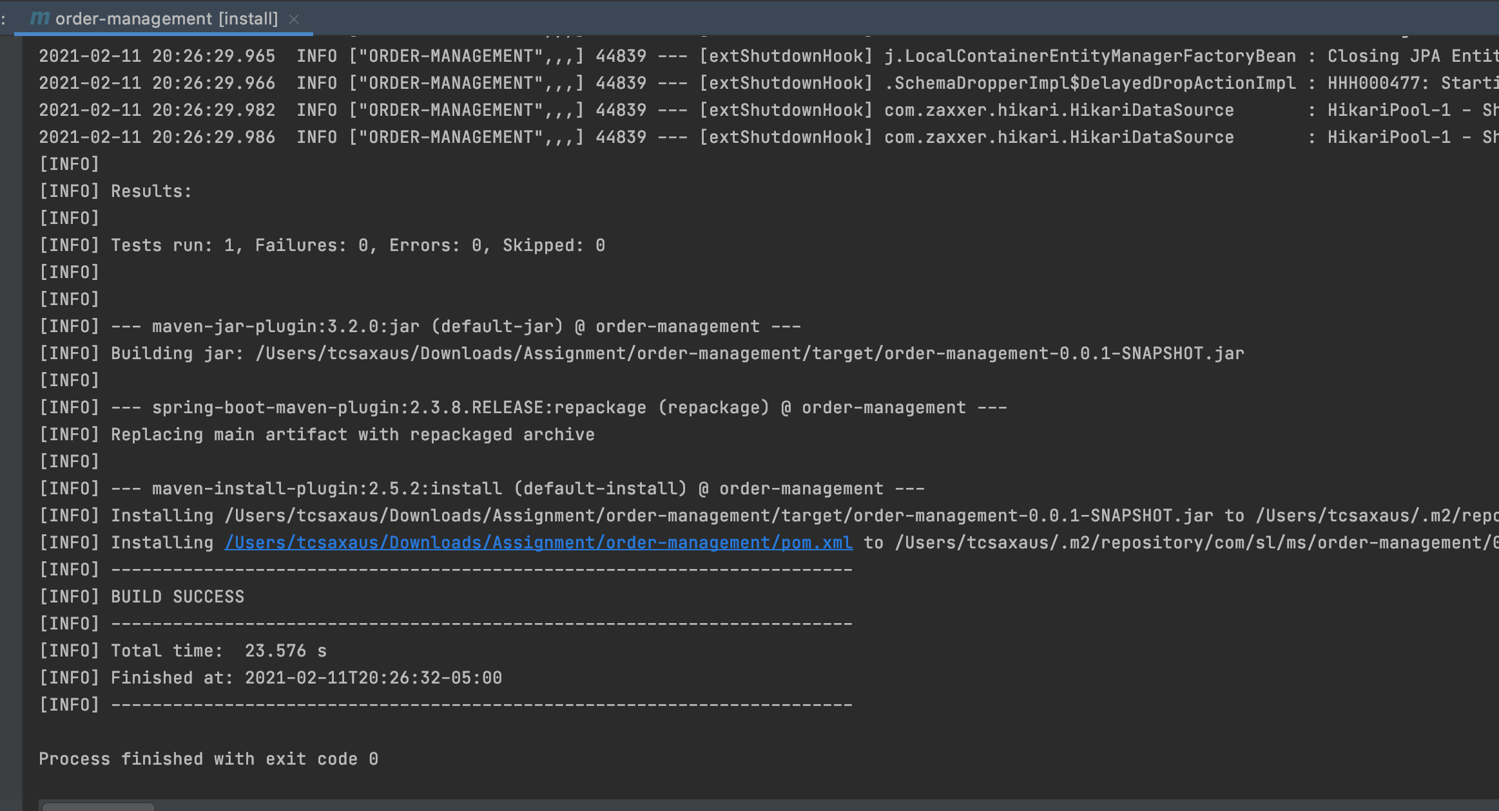

5. Evidence for additional task completion by executing /dev end point in postman and screenshot for yml config.

6. Verify the end point via POSTMAN.

4. Build of services should be possible with maven. Provide successful build screenshot for same.

5. Evidence for additional task completion by executing /dev end point in postman and screenshot for yml config.

6. Verify the end point via POSTMAN.

5. Evidence for caching implementation by showing api fetch before cache and after cache changes in response time & code/config screenshot.

6. Screenshot for logs generated.

7. Test hystrix by keeping Inventory Api down.

8. Check with logger able to use trace id for request from order api to inventory api.

9. Verify the end point via POSTMAN.

10. Code coverage of unit and integration tests is above 80%

